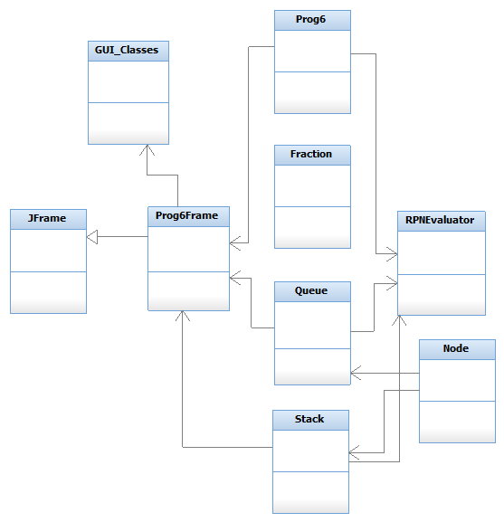**Class Diagram:**

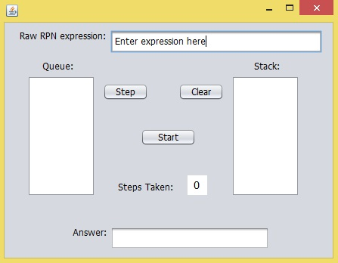**GUI Design:**

**Test Cases:**

|  |  |  |  |
| --- | --- | --- | --- |
| Test  Case | Description | Steps | Expected result / output |
| 1 | Testing minus two fractions | Step a: Click on text box raw RPN Expression.  Step b: Enter : (4/12) (2/12) - # Step c: Click Start | Answer: (1/6)  Steps: 3  Stack:  Queue: (2/12)  Raw RPN Expression: (4/12) (2/12) - # |
| 2 | Testing add two fractions | Step a: Click on text box raw RPN Expression.  Step b: Enter : (4/12) (2/12) + # Step c: Click Start | Answer: (1/2)  Steps: 3  Stack:  Queue: (1/2)  Raw RPN Expression: (4/12) (2/12) + # |
| 3 | Testing multiply two fractions | Step a: Click on text box raw RPN Expression.  Step b: Enter : (1/2) (1/2) * # Step c: Click Start | Answer: (1/4)  Steps: 3  Stack:  Queue: (1/4)  Raw RPN Expression: (1/2) (1/2) * # |
| 4 | Testing add and multiply | Step a: Click on text box raw RPN Expression.  Step b: Enter : (1/2) (1/2) (1/2) + * # Step c: Click Start | Answer: (1/2) Steps: 5 Stack:  Queue: (1/1) (1/2) Raw RPN Expression: (1/2) (1/2) (1/2) + * # |
| 5 | Testing minus and multiply | Step a: Click on text box raw RPN Expression. Step b: Enter : (1/2) (1/2) (1/2) - * Step c: Click Start | Answer: (1/4) Steps: 5 Stack:  Queue: (1/2)(1/4) Raw RPN Expression: (1/2) (1/2) (1/2) - * |
| 6 | Testing no expression no operands or operators | Step a: Click on text box raw RPN Expression Step b: Enter: # Step c: Click start | Answer: Invalid Expression!  Steps: 0  Stack:  Queue:  Raw RPN Expression: # |
| 7 | Testing clear | Step a: Click on text box raw RPN Expression.  Step b: Enter : (4/12) (2/12) - # Step c: Click Clear | Answer:  Steps: 0  Stack:  Queue:  Raw RPN Expression: |
| 8 | Testing mismatch number of operands and operators | Step a: Click on text box raw  RPN Expression.  Step b: Enter : (12/2) (21/2) + + #  Step c: Click Start | Answer: Invalid Expression!  Steps: 3  Stack:  Queue: (33/2)  Raw RPN Expression: (12/2) (21/2) + + # |
| 9 | Testing invalid input | Step a: Click on text box raw RPN Expression.  Step b: Enter : (2/9) B (4/3) / # #  Step c: Click Start | Answer: Invalid Expression!  Steps: 2  Stack:  Queue:  Raw RPN Expression: (2/9) B (4/3) / # # |
| 10 | Testing negative final value | Step a: Click on text box raw RPN Expression.  Step b: Enter : (1/2) (-2/1) + (6/5) - # Step c: Click Start | Answer: (-27/10)  Steps: 5  Stack:  Queue: (-3/2)(-27/10)  Raw RPN Expression: (1/2) (-2/1) + (6/5) - # |
| 11 | Testing clear then entering another expression | Step a: Click on text box raw RPN Expression.  Step b: Enter: (4/12) (2/12) - # Step c: Click Clear Step d: Click on text box raw RPN Expression.  Step e: Enter : (1/2) (-2/1) + (6/5) - # Step f: Click Start | Answer: (-27/10)  Steps: 5  Stack:  Queue: (-3/2)(-27/10)  Raw RPN Expression: (1/2) (-2/1) + (6/5) - # |
| 12 | Testing entering a RPN expression step | Step a: Click on text box raw RPN Expression.  Step b: Enter : (1/2) (-2/1) + (6/5) - # Step c: Click step once | Answer:  Steps: 1  Stack: (1/2)  Queue:  Raw RPN Expression: (1/2) (-2/1) + (6/5) - # |
| 13 | Testing entering a RPN expression steps | Step a: Click on text box raw RPN Expression.  Step b: Enter : (1/2) (-2/1) + (6/5) - # Step c: Click step twice | Answer:  Steps: 2  Stack: (1/2) (-2/1)  Queue:  Raw RPN Expression: (1/2) (-2/1) + (6/5) - # |
| 14 | Testing entering a RPN expression steps | Step a: Click on text box raw RPN Expression.  Step b: Enter : (1/2) (-2/1) + (6/5) - # Step c: Click step three | Answer:  Steps: 3  Stack:  Queue: (-3/2)  Raw RPN Expression: (1/2) (-2/1) + (6/5) - # |
| 15 | Testing entering a RPN expression steps | Step a: Click on text box raw RPN Expression.  Step b: Enter : (1/2) (-2/1) + (6/5) - # Step c: Click step three  Step d: Click start | Answer: (-27/10)  Steps: 5  Stack:  Queue: (-3/2)(-27/10)  Raw RPN Expression: (1/2) (-2/1) + (6/5) - # |